1.2 Implementation of Selenium with JMeterController 

This section will guide you:

* To implement Selenium with JMeter Controller in JMeter

**Development Environment:**

* Apache JMeter 5.1.1 Version
* JDK Runtime Environment 8.1

This guide has three subsections, namely:

1.2.1 Problem statement for implementing Selenium with JMeter

1.2.2 Solution for the problem statement

1.2.3 Pushing the code to GitHub repositories

**Step 1.2.1:** Problem statement for Processors, Assertions and Timers

* Objective: Implement Selenium with JMeter for a particular domain
* Steps involved:

1. Set up JMeter.
2. Create a test plan.
3. Add thread group.
4. Record the scripts.
5. Install WebDriver plugin.
6. Write Selenium scripts in WebDriver.
7. Run the scripts and view the results.

**Step 1.2.2:** Solution for the problem statement

1. Migrating plugins manager to JMeter.

* Download WebDriver plugins for JMeter.
* Download JMeter Plugin from “<https://jmeter-plugins.org/install/Install/>”.

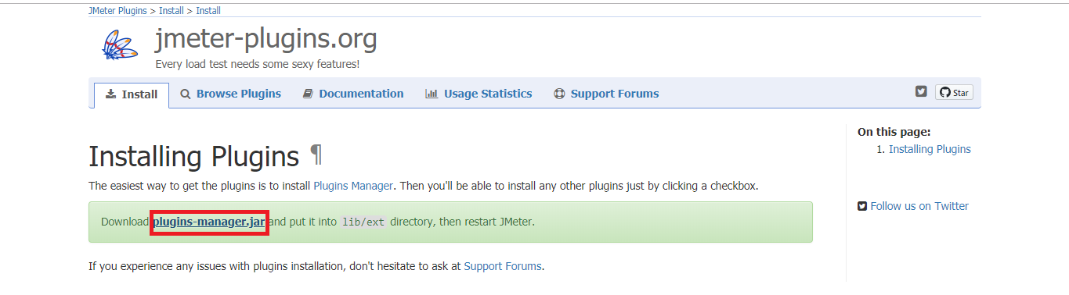

* Unzip JMeterPlugins-WebDriver 1.1.3 (version is default).
* The unzipped files must be copied to the lib folder -> ext folder of JMeter.

1. Installing WebDriver plugin

* Click on options -> click on plugins manager.

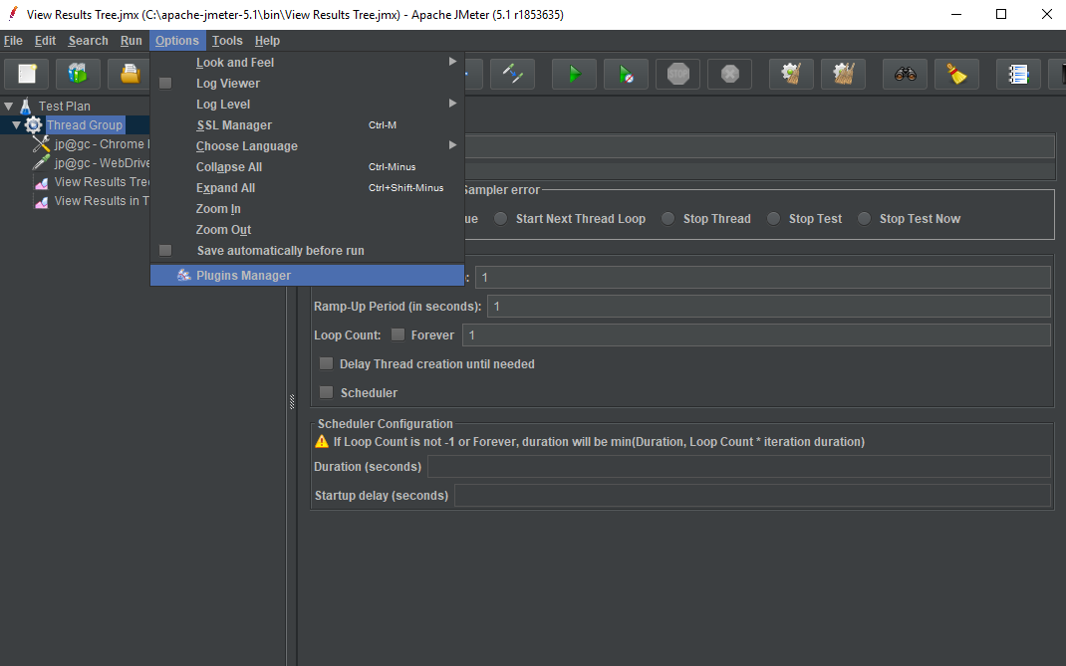

* Click on Available plugins -> click on Selenium/Web Driver Sampler.
* Click on the Restart and install button. (JMeter will automatically restart.)
* Click on install plugins -> click on Selenium/Web Driver Sampler.
* Click on the Restart and install button.(JMeter will automatically restart.)

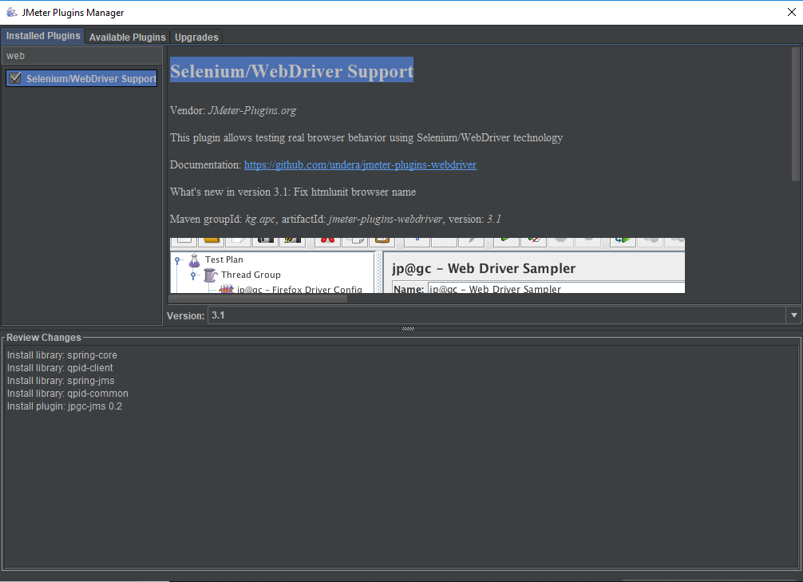

1. Writing your Selenium script.

* Right click on the Test Plan.
* Click on Add -> Thread(Users)->Thread Group.

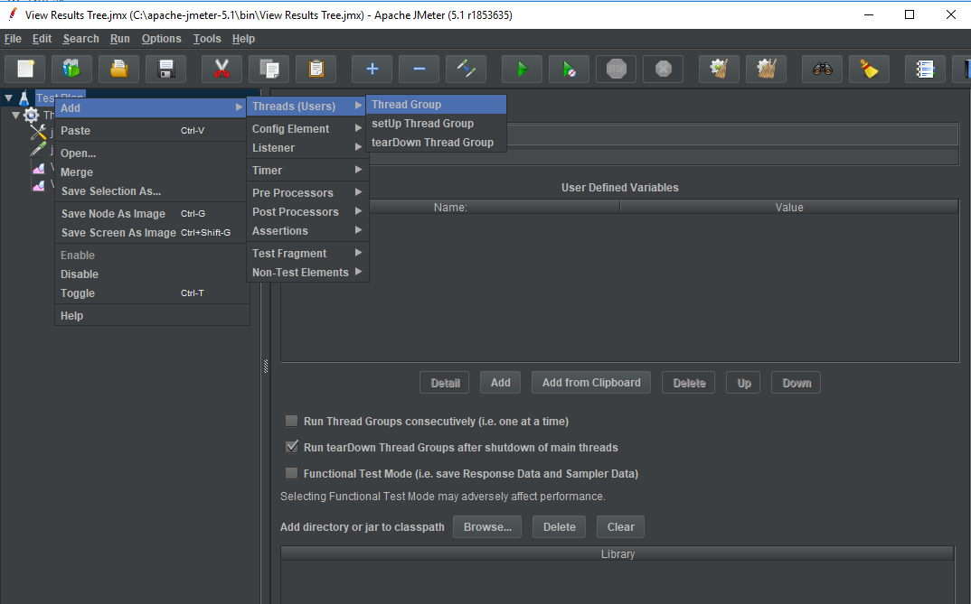

* Right click on Thread Group.
* Click on Add -> Config Element->jp@gc Chrome Driver Config.

You can also use Firefox driver.

* Click on Add ->Config Element ->jp@gc Firefox Driver Config.

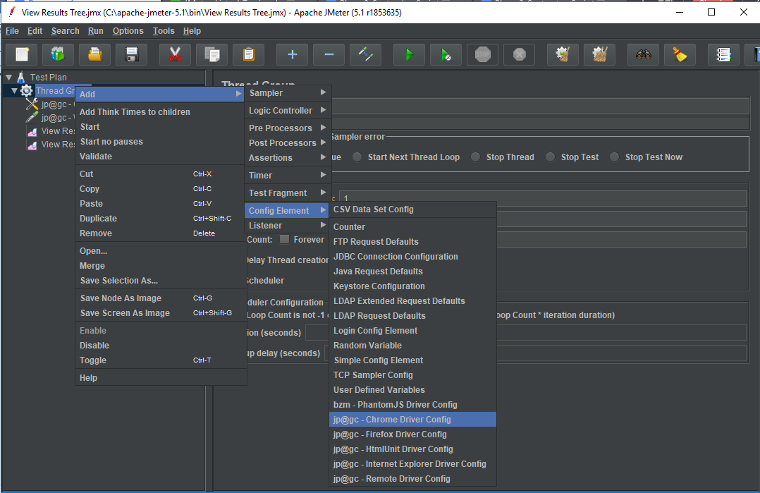

* Right click on Thread Group.
* Click on Add -> Sampler->jp@gc Web Driver Sampler.

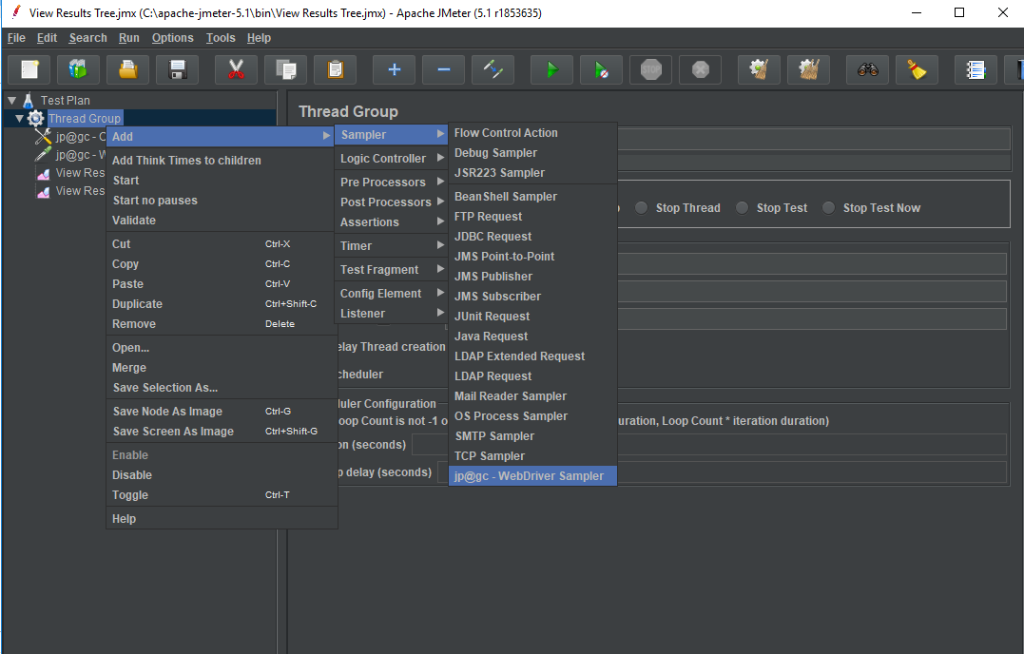

* Right click on Thread Group.
* Click on Add -> Sampler->Listener-> View Results in Tree.

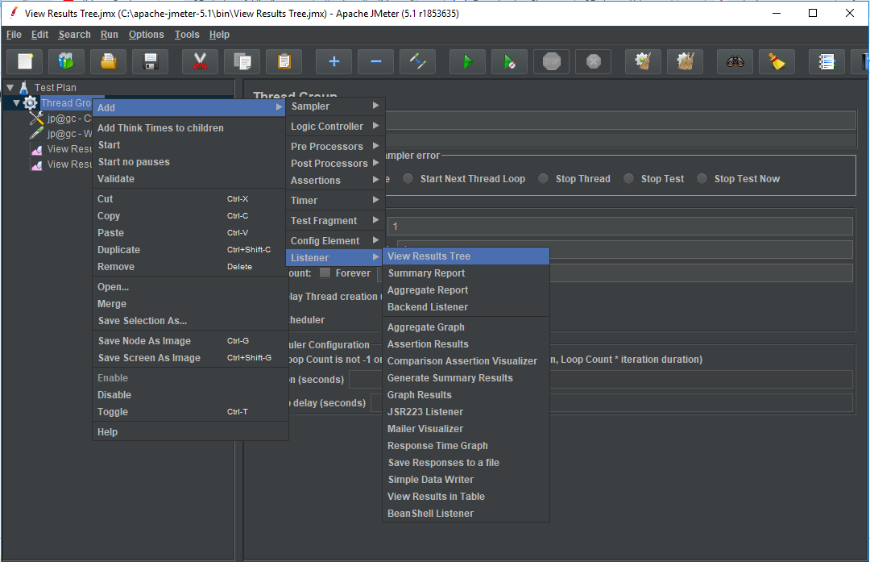

1. Running WebDriver tests in JMeter

* Click on jp@gc Chrome Driver Config.
* Enter your Chrome driver path.
* You can also use Firefox Driver Config.
* Enter your Firefox driver path.

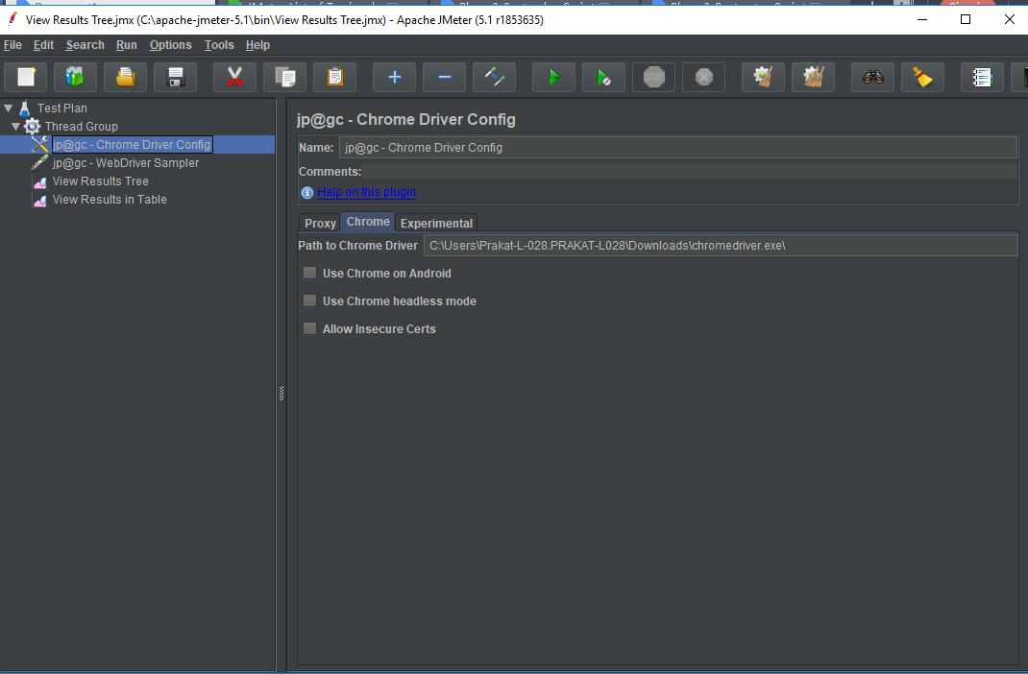

* Click on jp@gc Web Driver Sampler.
* Write your Selenium script.

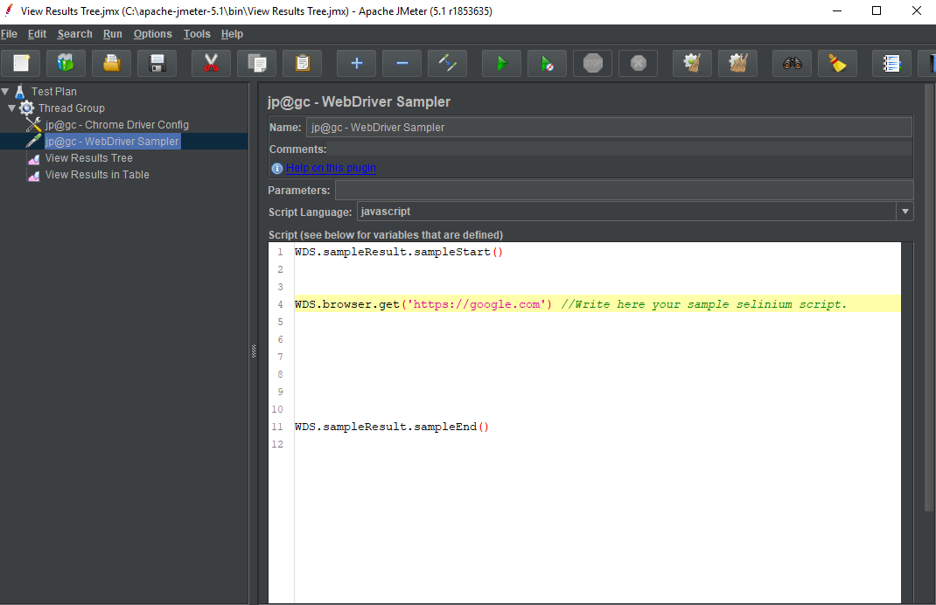

* Run the script.
* View the results in “View Results Tree”.

**Step 1.2.3:** Pushing the code to GitHub repositories

Open your command prompt and navigate to the folder where you have created your files.

cd <folder path>

Initialize your repository using the following command:

git init

Add all the files to your git repository using the following command:

git add . 

Commit the changes using the following command:

git commit . -m “Changes have been committed.”

Push the files to the folder you initially created using the following command:

git push -u origin master